EMERGENCY PROCEDURES – IN CASE OF ACCIDENT

In the case of an accident the first aid kit is located in the kitchen on the serving counter (to the left as you look).

The club also has several trained first aiders, they are:

Insert List

In the case that the accident requires professional medical attention the following information is useful:

Club Address: East Woodhay Cricket Club, East End, Newbury, Hampshire RG20 0AP

Nearest Doctors Surgery:

Woolton Hill Surgery, Trade Street, Woolton Hill, RG209UL Tel Number 01635 253324

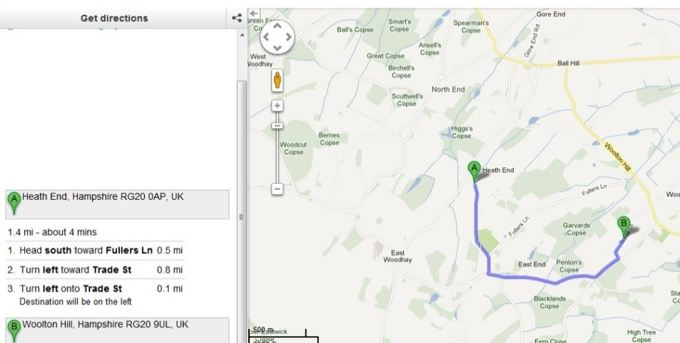

Nearest Hospital (A&E)
Basingstoke and North Hampshire Hospital, Aldermaston Road, Basingstoke, Hampshire,RG24 9NA.

